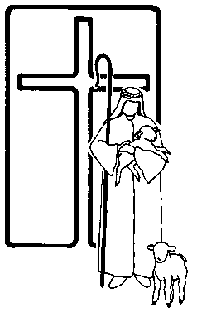 | Good Shepherd Lutheran Church  Activities and Resources for Children for November 28, 2021  Information and Announcements  for September 5, 2021

For Younger Children:

The Children’s Sermon link below, leads to a page that contains activities, a coloring page and puzzles related to the scripture.
Crown Him King Children's Sermon | Sermons4Kids

For Middle School and High School aged youth

The link below leads to a bible study.

https://drive.google.com/file/d/1Mjnlri9HNGV3KxOwva9XQQYYEr9xT-qP/view?usp=sharing

