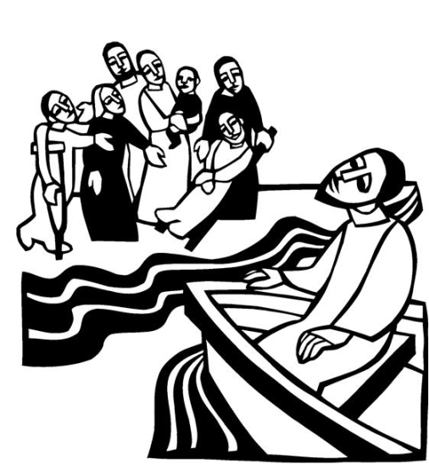 | [Jesus] said to them, “Come away to a deserted place all by yourselves and rest a while.” For many were coming and going, and they had no leisure even to eat.  Mark 6:31

Below are some activities children and youth can use at home for July 18th. The activities are related to the Gospel Lesson for July 18th (Mark 6: 30 – 34, 53-56).

For Younger Children:

Video Did Jesus ever get tired? - Bible Christian Resources - Audio, Video, Bible Studies, Christian Mobile Applications (bibleresources.info)
Children’s Sermon Rest in Jesus Children's Sermon | Sermons4Kids
(Rest in Jesus)

The next several pages are designed for younger children. These pages are courtesy of Sermons 4 Kids.

For Middle School and High School aged youth

The last 2 pages are a bible study for older children/youth.

Video Mark 6 | Bible.is You have to click on the arrows to get to verse 30

Group Activities
BOAT GAME: The teacher can tape off a specific area in the shape of a boat. Children can jump in and out of the boat as the teacher tells them what to do. The teacher could tell the children to jump OUT of the boat, or jump INTO the boat, or all jump to the back of the boat or to the front of the boat, etc, as time allows.
WORK, SCHOOL, PLAY AND REST: Label different areas of the designated room as WORK, SCHOOL, PLAY AND REST. When the teacher shouts one of those words, the children will run to that area and pantomime something for that area.. such as working in the WORK area, so sitting at a desk for the SCHOOL area, jumping or playing in the PLAY area and laying down quickly in the REST area. Keep children moving quickly to make the game more fun and using up alot of that extra energy that children have before story time.
BOOT CAMP: Tell children they are going to BOOT CAMP today. Teams can line up and do exercises, cadences, running, obstacle courses, etc as time allows. Other props for Boot Camp are great if the teacher has the time and ideas for dress up, hats, squirt guns, etc.
QUIET TIME: Tell children to gather around in a circle for a quiet place and rest, as teacher tells today's story.
VACATION PICTURES: Provide the children with supplies to color a favorite vacation place of their choice. Display the pictures on a classroom wall with today's Bible verse written on the wall above their vacation pictures.
REST AND RELAXATION ACROSTIC: The teacher can write REST AND RELAXATION down the left side of a large poster board and let the class find words for resting and being quiet before Jesus. Children can also draw pictures on this poster board for their ideas.
RESTFUL PUPPET: Each child can be given a small lunch bag to use as their RESTING puppet... drawing facial features with eyes CLOSED.. and write parts of today's Bible verse on the front and back of their bag puppet.. use their puppets to tell today's story or each child can use their puppet to ask a question to their classmates about how to be Quiet and restful when they need to get away.
STAINED GLASS PRAYING HANDS: Children can trace their hands or cut out a tracing that the teacher has given to them for the look of praying hands. Children can cut out a form of a glass window and glue their praying hands onto the window shape. Then let children glue very small pieces of tissue paper to the "stained glass window" shape around the hands.
RESTING PAPER PLATE: All the children can color a paper plate and cut slips around the edges of the plate. Write small words from today's lesson about being quiet and getting away from being too busy, etc. Children can use stickers and colorful markers to draw a picture of them relaxing and resting in the middle of the plat5e. The plate can then be taped or attached to a small stick or dowel, if desired.
BEE QUIET: Give children yellow and black construction paper, chenille wire, etc to cut out a bumble bee and glue or tape onto construction paper. Write BEE QUIET and get REST AND RELAXATION...Mark 6:30-32
SHARE A SNACK: Children can each spread out a towel and lay down for a quick REST time, singing a quiet song together, and then the teacher can pass out a snack for children to share as they rest, such as crackers and cheese, apple slices or pop corn!

