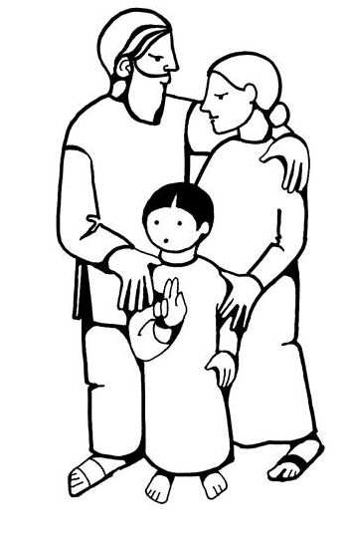 | “Whoever does the will of God is my brother and sister and mother.”  Mark 3:35

Below are some activities children and youth can use at home for June 13th. The activities for Younger Children relate to the First Reading for the day.

For Younger Children:

Video Adam and Eve - YouTube
Adam and Eve Sin - YouTube
Children’s Sermon Adam and Eve Children's Sermon | Sermons4Kids
(Adam and Eve)

The next 6 pages are designed for younger children. These pages are courtesy of Sermons 4 Kids.

For Middle School and High School aged youth

The last 2 pages are a bible study for older children/youth based on the Second Reading for the day. The video gives some ideas about who Paul was and his purpose. Paul is the writer of the Second Reading

Video The Origins of Christianity – Lesson 6: Paul’s Mission to the Gentiles

Group Activities
RUN AND HIDE: All the children will run and hide in some special area. The teacher will then say to the children... "Come out if you are wearing something blue, then come out if you have tennis shoes on, then come out if you have a ribbon in your hair, come out if you have on a tie, come out if you are wearing a necklace, etc. Children can come out when they have something in common in what the teacher calls out for and will sit in a circle for the following game.
SNAKE TOSS: The teacher can purchase 2 long rubber snakes from a Dollar Store and let the children divide into teams and have a "snake toss", to see which team can toss their snake the farthest. Someone will have to mark where each snake lands to see which team has the farthest throws.
HIDE AND SNAKE: The teacher can hide many rubber snakes that have been purchased from craft, dollar or retail store. Send the children out into the "garden" to find all the snakes and lay them at the foot of a tree and sit in a circle while today's Bible lesson is told to the children.
HIDE IN A CIRCLE: As children form a circle, the teacher can slip a small object in someone's hand and appoint another child to stand in the middle and try to decide which child is hiding the object. Pretend to slip the object in several children's hands so the appointed child in the middle will not know and will have to guess. Tell children that they can ALL act as if they have the object.
GARDEN WALKING: If there is a flower garden in the nearby area, children can be led to walk through or around a garden area, and even pick a flower to add to a flower vase when they return to the classroom. Ask children who made those beautiful flowers and what do they know about the Garden of Eden.
GARDEN PAINTING: Provide children with finger paints and large paper, wet wash clothes for clean up as well, and sponges to finger paint a large garden, using various objects and sponges to form different flowers. Finger paint GARDEN OF EDEN, on the picture if desired.
FINGER INK PRINT GARDEN: Give children construction paper and ink pads to form finger ink prints on the paper and then use markers to form the stems of the finger ink print flowers. Write words from today's Bible lesson for children to remember the lessons learned today.
FINGER PRINT FRUIT TREE: Provide children with a brown piece of paper in the shape of a tree to glue onto a large piece of construction paper. Children can tape a curled ribbon onto the trunk of the tree to represent the serpent, and make many INK finger prints as the leaves of the tree. Older children could use pen or thin markers and write a sin on each finger print in the tree.
FALLING DOMINOES: Children can be lined up on a floor space and given dominoes to line up very close to each other. Tell children that one SIN LEADS TO ANOTHER and we FALL when we sin! The first domino can be touched to fall and will continue to touch the next dominoes and all will continue to fall! The teacher can make several comparisons for the children when they see the dominoes falling, as questioning what the children know about sin and about Jesus willing to forgive.
SIN SERPENT CHAIN: Children can be given thin slips of paper to form a long loop chain to look like a snake in our story. Children can draw 2 eyes and tape or glue on a tiny piece of ribbon for the snake's tongue. Before gluing the slips of paper together in the loop, children should write one sin on each slip of paper/loop and then glue loops together.
SING A SONG: O BE CAREFUL LITTLE EYES; THIS LITTLE LIGHT OF MINE.
SHARE A SNACK: Children can be given an APPLE to represent today's fruit or any other fruit that the teacher desires. Apples can be sliced and have a fruit dip or peanut butter or cream cheese for dipping.

