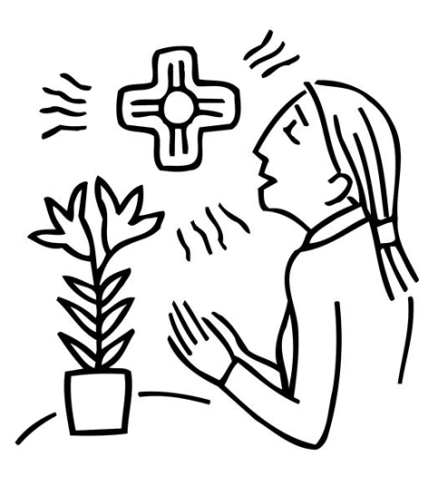 | If we confess our sins, God who is faithful and just will forgive us our sins and cleanse us from all unrighteousness.  1 John 1:9

Below are some activities children and youth can use at home for April 18th. The activities for younger children relate to the story of Jonah and the whale. The activities for older youth are related to the Second Lesson for the day.

For Younger Children:

Video: Jonah and the Fish - YouTube

Jonah Disobeys God Children's Sermon | Sermons4Kids (Jonah Disobeys God )

The next 5 pages are designed for younger children, but you might be able to play some of the games with older children as well.

For Middle School and High School aged youth

The last 2 pages are a bible study for older children/youth. Watch the video first, then read the scripture, before doing the bible study

Video:
1 John in 5 minutes! - YouTube

Group Activities

HIDE AND GO SEEK: Play this game like the normal Hide and Go Seek game. After the game is over, explain to the children that they cannot hide from God. He always knows where we are and what we are doing.

PIN JONAH IN THE FISH: Draw a large poster picture drawing of a BIG bright blue fish and a small picture of a little man (Jonah). Children can be blind folded and turned around a couple of times and then try to pin JONAH into the fish! Everyone gets a turn.

STICK FISH: Give the children 4 craft sticks to form triangles together to create a fish and the tail. Glue the sticks together. Children can paint or color the inside of the fish and write words around their picture from today's story, such as Don't Run from God, don't Hide from God, or "oh oh Jonah, you should have gone to Ninevah!"

FISH ON A STICK: Give cardstock paper and markers to the children to draw and cut out a large fish that can be taped to the top of a craft stick or a longer paint stick. Let the children tell the story of Jonah using their fish sticks. If time permits, the story can be told using other props such as a boat, a fish, sailors glued to craft sticks if desired.

GELATIN AQUARIUM: Give the children can supplies to make some BLUE gelatin (with adult help). Using ice instead of water helps the Jello to set quickly. Add some fish candy to the "aquarium" see through plastic cups! A strip of paper with words from our lesson today can be taped to the small see through cup aquarium.

PAPER PLATE FISH: Let the children color a paper plate with a bright blue colored marker or crayon. Cut a triangular piece from one side of the paper plate to create the fish's mouth. Tape the cut out piece to the other side of the paper plate to create the tail of the big fish! Draw an eye and other things to make the paper plate to look like a fish.

JONAH PUZZLE: The teacher will prepare an envelope for each child with a cut up picture of the BIG FISH inside each envelope for children to try to piece together. When pieced together to form the big fish, glue the fish onto a piece of blue construction paper and write words from today's lesson around the top and sides to remind children of the lessons learned today.

STUFFED FISH: Give each child two blue pieces of paper with two identical tracings of a big fish. Place the two fish together and hole punch around the edges of the fish and let children use yarn to lace the fish together and stuff them with tissues before sealing it off. Write a title on that big fish to remember not to try to hide from God!

SING A SONG:
Who Did Swallow Jonah?

SHARE A SNACK:
Goldfish crackers and blue Kool-Aid.

